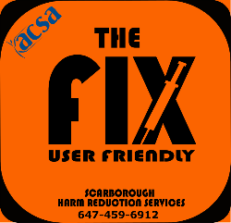

**Scarborough Mobile Delivery**



Questions or in need of additional support?

**CALL OR TEXT US AT:**

647-459-6912

**OR**

416-554-9245

**SUPPLIES:**

Harm Reduction & Drug Use equipment

* Pipes
* Foils
* Injection equipment
* Straws
* Cookers
* Sterile water
* Alcohol swabs
* Etc.

Call or text ***“supplies needed”***, your main intersection and the supplies you need to: 647-459-6912

**OR**

416-554-9245

**Referrals and Services**

* Housing
* Tax support
* Counselling supports
* Health care
* Food banks/drop-in centres
* Snacks

Text us at:

**647-459-6912**

**OR**

**416-554-9245**

and simply indicate the service you need. Someone will text or call you back a.s.a.p.

**Monday-Friday (varied times)**

**Some limited delivery on Sat/Sun**